Sri Lanka Institute of Information

Technology



Lab Submission

<Lab sheet No 05>

**<IT24101049>**

**<Rajapaksha K.N.>**

**Probability and Statistics |IT2120**

B.Sc. (Hons) in Information Technology

1.

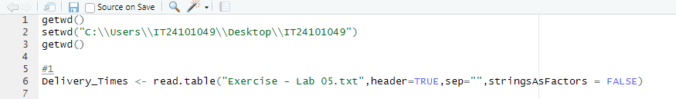

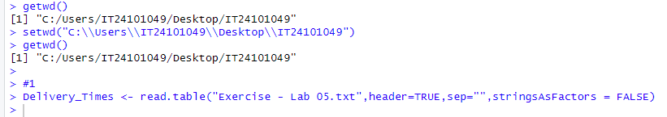

2.



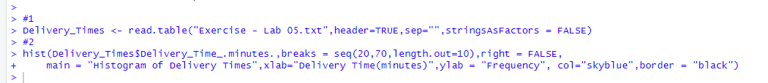

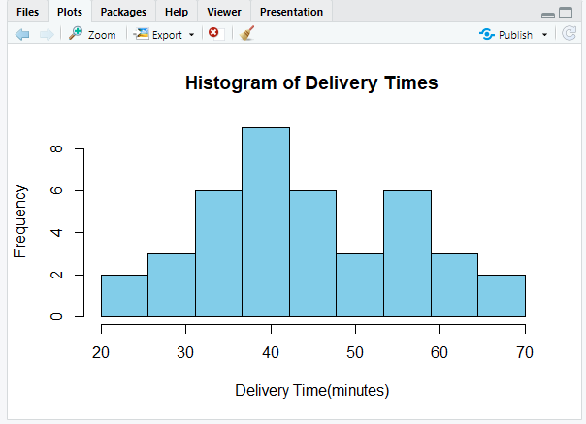

3.

The delivery times have one main peak and look even both sides. Most deliveries take about 35-45 minutes. It looks somewhat like a normal distribution.

4.

